**“VIRTUAL ASSISSTANT”**

**A Minor Project Synopsis & SRS Submitted to**



**Rajiv Gandhi Proudyogiki Vishwavidhyalaya, Bhopal**

**Towards Partial Fulfillment for the Award of**

**Bachelor of Engineering**

**(Computer Science and Engineering)**

**Submitted By:**

**Dipesh Paul (0827CS151066)**

**Gayyur Qureshi (0827CS151073)**

**Harshdeep Totlaney (0827CS151077)**

**CS-2(Third year)**

**Supervised By: Guided by:**

**Mr. Anil Patidar Mr. Deepak Agrawal**

**Ms. Zeba Qureshi**

**Ms. Nupur Agrawal**

**Mr. Kapil Vyas**



**Department of Computer Science and Engineering**

**Acropolis Institute of Technology and Research, Indore**

**Jan-June 2018**

**CONTENT**

|  |  |  |  |
| --- | --- | --- | --- |
| **S. NO.** | **TOPIC** | **PAGE NO.** | **REMARK** |
| 1. | Title | 1 |  |
| 2. | introduction | 1 |  |
|  | 2.1 project benefits | 1 |  |
|  | 2.2 project scope | 2 |  |
| 3. | problem statement | 2 |  |
| 4. | objectives | 2 |  |
| 5. | intented user | 2 |  |
| 6. | exixting system | 3 |  |
|  | 6.1 process flow | 3 |  |
|  | 6.2 limitations | 3 |  |
| 7. | proposed system | 4 |  |
|  | 7.1 system features | 4 |  |
|  | 7.2 process flow | 4 |  |
|  | 7.3 hardware requirements | 5 |  |
|  | 7.4 software requirements | 5 |  |
| 8. | expected outcomes | 5 |  |
| 9. | conclusion | 5 |  |
|  | 9.1 limitations | 5 |  |
|  | 9.2 future enhancements | 5 |  |
| 10. | references | 6 |  |

**SYNOPSIS**

1. **TITLE**

VIRTUAL ASSISSTANT BASED ON ARTIFICIAL INTELLIGENCE

1. **INTRODUCTION**

A virtual assistant name ‘Alan’ (typically abbreviated to VA, also called a virtual office assistant) is generally self-employed and provides professional administrative, technical, or creative (social) assistance to clients remotely from a home office. A virtual assistant is a software agent that can perform tasks or services for an individual. A Virtual assistant is based on Artificial Intelligence techniques. Sometimes the term "chat bot" is used to refer to virtual assistants generally or specifically those accessed by online chat. Our virtual assistant can perform the various tasks such as set a remainder, weather forecasting, and it can communicate with you like a human. It can perform the internet search and also provide you the latest news. We will also create a login page through which any user can log in. When next time user will search for the same problem he will get the solution easily. Basically, it is a web app so it is available on every platform.

**Modules:**

* Admin Login
* User Login
* Chat Bots
* Weather Forecast
* Reminder
* Game
* Notes
* Calendar
  1. **PROJECT BENEFITS**

1. Any human can interact with Assistant
2. Weather Forecast
3. Stay better informed for any information
4. Human can use assistant for entertainment.
5. It bridges the gap between humans and technology.
6. Gaining extra knowledge from the internet is just one click.
   1. **PROJECT SCOPE**

The scopes of this project are:

* Any humans can use this system as it is not client centric.
* All the queries asked by human can be done using this system.
* Human can communicate with Virtual Assistant.
* Database Support & Maintenance after deployment to production.
* Provides interface between the human and internet.
* Assistant can perform all the task provided by human.
* Assistant can learn from humans while interacting.
* Storing all records.

1. **PROBLEM STATEMENT**

Many unpredictable factors may affect a human life. Due to their busy schedule they are not able to interact with any other human. Since it is available on web anyone can access it from any platform.

**4. OBJECTIVES**

1. Our objective is to create a virtual assistant that can assist human virtually.
2. The assistant has various features such as chat, set reminder, perform search, play games and more.

**5. INTENDED USER**

The intended user is each and every Human Being.

**6. EXISTING SYSTEM**

A **virtual assistant** (typically abbreviated to **VA**, also called a **virtual office assistant**) is generally self-employed and provides professional administrative, technical, or creative (social) assistance to clients remotely from a home office. Increasingly Virtual Assistants are utilizing technology such as Skype as well as Google Voice. As of now existence virtual assistant are Google Assistant and Siri are most commonly found. They neck-to-neck when it comes to organizing and planning the user’s tasks. While Siri has an advantage seamless connection with third party apps such Twitter, Uber, etc, Google Assistant has the support of all its in-house apps. When it comes to choosing a winner, Google Assistant wins by a long shot, while Microsoft’s Cortana has a long way to go, seeing how the race between AI-powered VAs is increasing day by day.

**6.1 PROCESS FLOW**

Output to User

Input from user

Figure 1: Process Flow of Existing System – “Virtual Assistant”

**6.2 LIMITATIONS**

Some limitations of the existing system are:

1. Not available at each and every platform.
2. Existing system is not fully automated.
3. Every information available may or may not be precise.
4. Internet required

**7. PROPOSED SYSTEM**

A virtual assistant (typically abbreviated to VA, also called a virtual office assistant) is generally self-employed and provides professional administrative, technical, or creative (social) assistance to clients remotely from a home office. A virtual assistant is a software agent that can perform tasks or services for an individual. Sometimes the term "chatbot" is used to refer to virtual assistants generally or specifically those accessed by online chat. Our virtual assistant can perform the various tasks such as set a remainder, weather forecasting, and it can communicate with you like a human. It can perform the internet search and also provide you the latest news. We will also create a login page through which any user can log in. When next time user will search for the same problem he will get the solution easily. Basically, it is a web app so it is available on every platform.

**7.1 SYSTEM FEATURES**

* Any human can interact with Assistant
* Weather Forecast
* Stay better informed for any information
* Human can use assistant for entertainment.
* It bridges the gap among humans and technology.
* Gaining extra knowledge from the internet is just one click.

**7.2** **PROCESS FLOW**

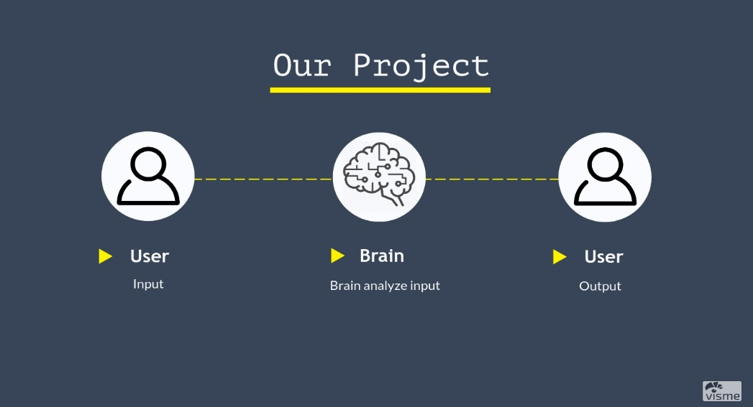

Figure 2: Process Flow Of Proposed System

**7.3 HARDWARE REQUIREMENT**

* Any system that has an Internet connection and microphone
  1. **SOFTWARE REQUIREMENT**
* Any Web Browser

**8. EXPECTED OUTCOMES**

* Assisting humans virtually.
* Learning from humans virtually.
* Perform various tasks and gives appropriate output.

**9. CONCLUSION**

This is to conclude that the project that we undertook was worked upon with a sincere effort. Most of the requirements have been fulfilled up to the mark and the requirements which have been remaining, can be completed with a short extension. This project would definitely satisfy all the requirements of the user and would be beneficial for the humans.

**9.1 LIMITATIONS**

1. Internet is required.
2. GUI is only in English.
3. The web portal will be constrained by the capacity of the database. Since the database is shared it may be forced to queue incoming requests and therefore increase the time it takes to fetch data.
4. Output may or may not be precise.
   1. **FUTURE ENHANCEMENTS**

* Can be integrated for home automation.
* Advancing with help of machine learning.
* Payment modes.
* Assistant can be used in IOT(Internet of Things)

**10. REFERENCES**

* https://www.python.org
* https://www.rivescript.com
* https://p5js.org/libraries
* <https://en.wikipedia.org/wiki/Virtual_assistant_(occupation)>
* https://www.theworkathomewoman.com/virtual-assistant
* https://analyticsindiamag.com/virtual-assistants-siri-cortana-google-assistant

Signature of the Candidate Signature of the supervisor